O Praise The Name

[Verse 1]

G
I cast my mind to Calvary
D Em
Where Jesus bled and died for me
C D G
I see His wounds, His hands, His feet

D G
My Saviour on that cursed tree

G D

[Verse 2]

G
His body bound and drenched in tears
D Em
They laid Him down in Joseph's tomb
C G
The entrance sealed by heavy stone
D G
Messiah still and all alone

G D

[Chorus 2]

G C G
O praise the Name of the Lord our God
Em D
O praise His Name forever - more
G C G
For endless days, we will sing Your praise
C D G
Oh Lord, oh Lord our God

[Verse 3]

G
Then on the third, at break of dawn
D Em
The Son of heaven rose again
C G
O trampled death, where is your sting
D G
The angels roar for Christ the King
G D

[Chorus 3]

G C G
O praise the Name of the Lord our God
Em D
O praise His Name forever - more
G C G
For endless days, we will sing Your praise

C D G
Oh Lord, oh Lord our God

[Verse 4]

G
He shall return in robes of white
D Em
The blazing sun shall pierce the night
C G
And I will rise among the saints
D G
My gaze transfixed on Jesus' face

G D

[Chorus 4]

G C G
O praise the Name of the Lord our God
Em D
O praise His Name forever - more
G C G
For endless days, we will sing Your praise
C D Em D
Oh Lord, oh Lord our God
C D G
Oh Lord, oh Lord our God

- SOFT V1 V2
- CHILL C2
- CHILL V3 BUILD AT “O TRAMPLED DEATH”
- LOUD C3
- SOFT V4
- CELEBRATORY C4, HOLD G

HOW GREAT THOU ART
Paul Baloche

VERSE 1:
G C/G
O Lord my God, when I in awesome wonder,
G D G
Consider all the worlds Thy hand hath made
G C/G
I see the stars, I hear the rolling thunder,
G D G
Thy power throughout the universe displayed

CHORUS 1:
G C G
Then sings my soul, my Savior God, to Thee
Am D G
How great Thou Art, How great Thou Art
G C G
Then sings my soul, my Savior God, to Thee
Am D G
How great Thou Art, how great Thou Art

Em C G/B D

VERSE 2:
A D/A
And when I think that God, His Son not sparing,
A E A
Sent Him to die, I scarce can take it in
A D/A
That on the cross, my burden gladly bearing
A E A
He bled and died to take away my sin

CHORUS 2:
G C G
Then sings my soul, my Savior God, to Thee
Am D G Am Bm
How great Thou Art, How great Thou Art
G C G
Then sings my soul, my Savior God, to Thee
Am D G
How great Thou Art, how great Thou Art

Em C G/B D

VERSE 3:
A D/A
When Christ shall come with shout of acclamation
A E A
And lead me home, what joy shall fill my heart
A D/A
Then I shall bow with humble adoration
A E A
And then proclaim, my God, how great Thou art

CHORUS 3:
G C G
Then sings my soul, my Savior God, to Thee
Am D G Am Bm
How great Thou Art, How great Thou Art
G C G
Then sings my soul, my Savior God, to Thee
Am D Em
How great Thou Art, how great Thou Art
Am D G
How great Thou Art, how great Thou Art

- V1 CHORUS 1 GUITAR PLUCK AND PADS
- VERSE 2 MARCHING BEAT STRUM
- CHORUS 2 EXPRESS
- VERSE 3 SOFT, BUILD UP AT LAST LINE
- LOUD LAST CHORUS, DIAMOND AT Em
- FADE OUT

ALABASTER JAR

Intro:
E B/D# C#m A

Verse 1:
E
This alabaster jar
B/D#
is all I have of worth
C#m7
I break it at Your feet, Lord
A
It's less than You deserve
E
You're far more beautiful
B/D#
More precious than the oil
C#m7
The sum of my desires
A
and the fullness of my joy

PreChorus:
C#m7
Like You spilled Your blood,
A C#m7
I spill my heart as an offering
B7
to my King

Chorus:
E B/D#
Here I am , take me
C#m7 A
As an offering
E B/D# C#m7
Here I am , giving every heartbeat
A E B7 C#m7 A
For Your glory take me

Verse2:
E
This time that I have left
B
is all I have of worth

C#m7
I lay it at your feet Lord,
A
its less than you deserve.
E
And though I’ve little strength,
B
and though my days are few,
C#m7
You gave your life for me
B A
so I will live my life for you.
Prechorus

Expressive Chorus x2

Bridge x 4 Soft, Medium, Loud:
E
Worthy, Worthy
Bsus4
You are worthy
C#m7 A
Worthy is the Lord

Loud Chorus
E B/D#
Here I am , take me
C#m7 A
As an offering
E B/D# C#m7
Here I am , giving every heartbeat
A E
For Your glory take me x2

- NO DRUMS TILL V2, NO BASS TILL CHORUS
- SOFT V1 STRUM AND VIOLIN/EGIG RIFF
- STRUM PRECHORUS PADS
- SOFT CHORUS, STRUM ON CHORD, BASS ENTER
- VERSE 2 DRUMS AND MORE BASS
- BUILD PRE CHORUS AND CHORUS X2 EXPRESS
- BUILDING BRIDGE UP TILL LOUD CHORUS

WHAT A FRIEND (D117)

1:
D G
What a friend we have in Jesus,
D A7
All our sins and griefs to bear!
D G
What a privilege to carry,
D A7 D
Ev’rything to God in prayer!
A7 D
O what peace we often forfeit,
G D A
O what needless pain we bear,
D G
All because we do not carry,
D A7 D
Ev’rything to God in prayer!

D A

2:
D D7 G
Have we trials and temptations?
D Bm7 E A7
Is there trouble anywhere?
D D7 G
We should never be discouraged,
D Em7 A7 D
Take it to the Lord in prayer.
Em7 A7 D D7
Can we find a friend so faithful,
G D Em7 A7
Who will all our sorrows share?
D D7 G
Jesus knows our ev’ry weakness,
D Em7 A7 D
Take it to the Lord in prayer.

D B

3:
E E7 A
Are we weak and heavy laden,
E C#m7 F#m7 B7
Cumbered with a load of care?
E E7 A
Precious Saviour, still our refuge,
E F#m7 B7 E
Take it to the Lord in prayer.

F#m7 B7 E E7
Do thy friends despise, forsake thee?
A E F#m7 B7
Take it to the Lord in prayer,

E E7 A Am
In His arms He’ll take and shield thee,
E F#m7 B7 E
Thou wilt find a solace there.

F#m E A E

- EGIG INTRO WITH EVERYONE
- UPBEAT
- KEY CHANGE AT 3

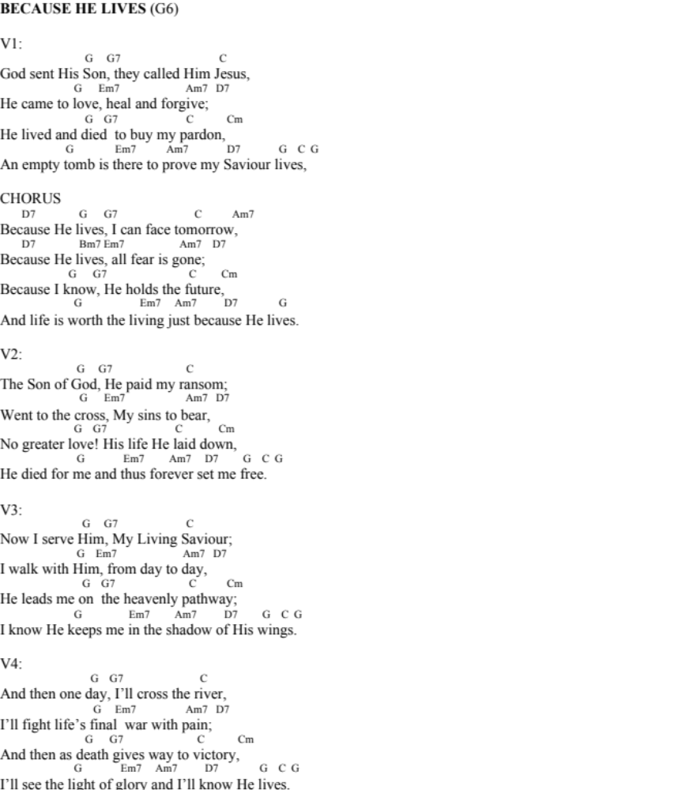
- HAPPY UPBEAT
- GUITAR DRIVING
- V1 CHORUS V2 CHORUS V3 CHORUS
- SOFT V4 SOFT CHORUS (?)
- WHEN REPEATING LAST LINE OF CHORUS, LAST G TURN INTO Em C
Father (CAPO -1)

Verse 1
E B
Your plans are greater
C#m A
They give me hope, a future
E B
Your promises I turn to
C#m A
When all things turn against me

Pre-Chorus 1
C#m A
You always heard my prayer
E B
Lord, I pour my heart to you
C#m A
In reaching for a helping hand
E B
I find life’s perfect as you’ve planned

Chorus 1
E B
You’re my Father
C#m A
You’ve ransomed me
B
You know what’s best for me
E B
You’re my Father
C#m B A
Who gave me Hope in the darkness
C#m B A
You taught me how to live
B
In your light

1, 2, 3, 4,

Verse 2
E B
Our times are in your hands
C#m A
In you we live and learn to be
E B
So take our hands and lead us
C#m A
Into life so full and free

Pre-Chorus 2
C#m A
You always heard my prayer // Call on me

E E4 B
Lord, I pour my heart to you // And you will see (3rd harmony)
C#m A
In reaching for a helping hand // Your life is in my hands
E B
I find life’s perfect as you’ve planned // You’ll find life’s perfect as I’ve planned. (as you’ve planned harmony)

Chorus 2
E B
You’re my Father // I am
C#m A
You’ve ransomed me // I’ve ransomed you
B
You know what’s best for me // I know what’s best for you
E B
You’re my Father // I am
C#m B A
Who gave me Hope in the darkness // I am your light in the darkness
C#m B A
You taught me how to live // Abide in me and you will
B
In your light // live right

C#m B A

Bridge (X2)
C#m B
You gave your all to set me free
A
I’ll never know the cost
C#m B
You loved in spite of wrath for me
A
The greatest love of all

Last Bridge
C#m B
You gave your all to set me free
A
I’ll never know the cost
C#m B
You loved in spite of wrath for me
A B
The greatest love of all

Pre-Chorus 3
C#m B
You always heard my prayer // Call on me
A E B
Lord, I pour my heart to you // And you will see (3rd harmony)
C#m B
In reaching for a helping hand // Your life is in my hands
A
I find life’s perfect as you’ve planned // You’ll find life’s perfect as I’ve planned. (as you’ve planned harmony)

Chorus 3

E B
You’re my Father
C#m A
You’ve ransomed me
B
You know what’s best for me
E B
You’re our Father (harmonies and soft guitar enter)
C#m B A
Who gave us Hope in the darkness
C#m B A
You taught us how to live
B C#m
In your light
B A B
You taught us how to love in your light
C#m B A
You taught us how to be in your light

Notes:
echo don’t drown harmony
harmony
trio, instruments are support

- V1 PC1 GUITAR ONLY
- C1 BASS ENTER
- V2 DRUMS ENTER
- PC2 DIAMONDS
- C2 EXPRESS
- DIE DOWN BEFORE BRIDGE
- BRIDGE 3 LAYERS ADD 1 EACH TIME
- INTENSE PC WITH DIFFERENT CHORDS
- SILENT LAST CHORUS, VOICE ONLY AT ‘YOU’RE OUR FATHER’

